Chapter 3 – Getting Started with JavaScript

Contents

JavaScript!!!!!! 2

JavaScript Values 2

JavaScript Number Type! 2

JavaScript Strings!!! 2

JavaScript Conditions!!! 3

Boolean expressions 3

Short-circuiting 3

isNan 3

If Statement 3

Switch statement 4

Test if a variable has a value 4

Evaluating equality 5

Rules for naming variables 5

JavaScript functions!!!!! 5

Declaration of a Function 5

Storing a function is a variable 5

Special notes about calling JavaScript functions 6

JavaScript Pop-ups! 6

JavaScript variable scope 7

Converting between types 8

JavaScript loooooooooops!! 8

While loop 8

Do While loop 9

For loop 9

Handling Errors: Try Catch Finally 9

# JavaScript!!!!!!

So I hear you want to learn about JavaScript. Well your in luck because I am going to describe everything you need to know about this amazing language. Your welcome! Enjoy the contents below!!!!!!!!!!!!

## JavaScript Values

Yeah so JavaScript thinks its super cool because it has these things called values. They aren’t so special! Well actually they are quite special. Basically every variable in JavaScript can equal one of the following:

* **Object:** an object is an object is an object.. it’s a just a normal object..
* **Primitives:** int, short, long, Boolean, string, char, etc.
* **Function:** you know, like those things you call in your program to do things.

**You can determine the value of a variable by using the typeof(variableName) function**

## JavaScript Number Type!

The number type is a number, obviously. You can represent a number in various ways. You can have a plain number like 1 or 2. But that’s boring. Here are some special ways to represent a number.

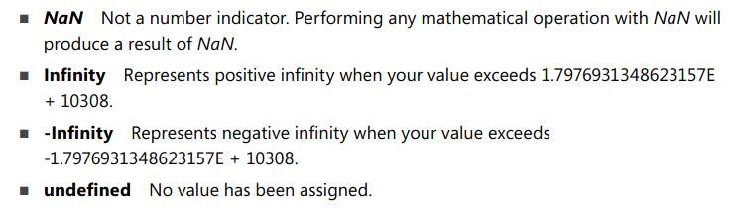

## JavaScript Strings!!!

Strings, strings, the magical yarn, the more you create, the larger sweater you will have when your grandma knits it!! Actually these aren’t strings that your grandma can knit. They are actually computer bits that you string together to make sentences!!! See what I did there? Here are some fun things you can do with strings!

* **Declaring a string can be done with single quotes or double quotes**
  + ‘this is a valid string’
  + “this is a valid string”
* **You can place single quotes inside of a double quotes string and vice versa**
  + ‘this “is” a valid string’
  + “this ‘is’ a valid string”
* **Escaping quotes!**
  + “this \”is\” a valid string”
  + ‘this \’ is \’ a valid string’
* **Concatenating strings!**
  + “this” + ‘is’ + ‘a’ + “valid” + ‘string’

## JavaScript Conditions!!!

That person lied?? Oh they were actually telling the truth?? Well make up your mind already!! Just use Booleans to represent whether what’s being said is true or false. It’s easier than this back and forth drama.

### Boolean expressions

* **And** is “&&”
* **Or** is “||”
* **Not** is “!”
* **Math expressions:** <=, >=, >, <

### Short-circuiting

JavaScript evaluates the left side of an expression before the right side. In cases where you have something like “false and true”, the left side evaluates to false, so the right side won’t even get read by the compiler.

### isNan

**isNan(object)** function can be used to see if an object is a number

### If Statement

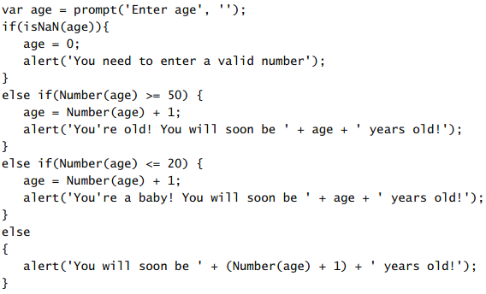

### Switch statement

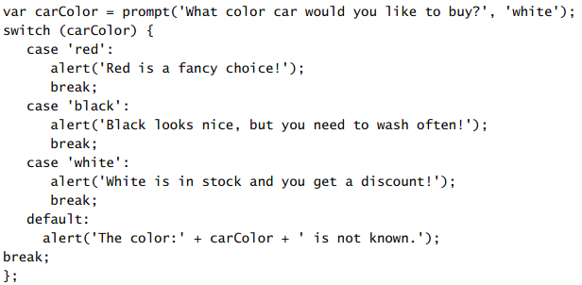

### Test if a variable has a value

* **Using an if statement**

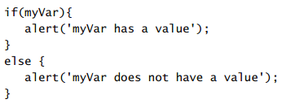

* **Coalesce operator**

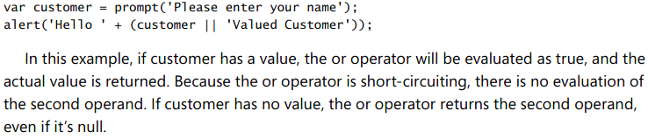

* **Chaining coalesce operators**

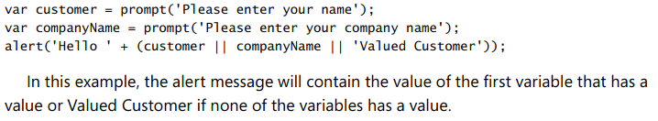

### Evaluating equality

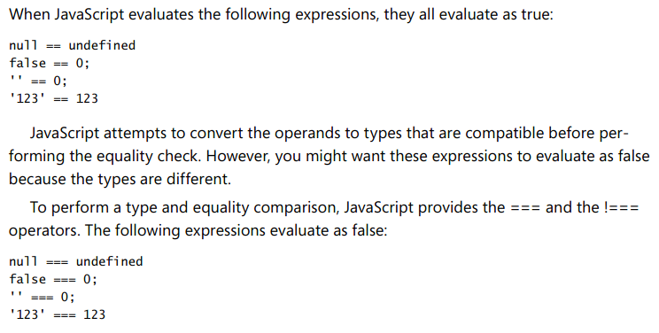

## Rules for naming variables

Yeah JavaScript complains if you name your variables badly. So you need to make sure you conform to the following naming convention:

* Cannot begin with numbers
* Cannot contain math or logical operators (-, +, *, etc)
* No punctuation marks (!, #, @, &, etc.)
* _ and $ are allowed
* No spaces
* Cannot be a JavaScript keyword
* Camel case!

## JavaScript functions!!!!!

JavaScript functions are pretty great! And there’s some things that are worth knowing about them! Thankfully for you I will tell you everything you might want to know about them!!!!

### Declaration of a Function

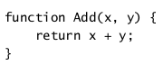

### Storing a function is a variable

The cool thing about this is that the variable is now of type function! So if you said typeof(addFunction), then it would return Function.

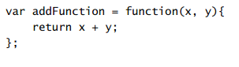

### Special notes about calling JavaScript functions

* If you call a JavaScript function with too many arguments, then JavaScript will discard the extras.
* If you call a JavaScript function with too few arguments, then the missing arguments will be passed as undefined.

## JavaScript Pop-ups!

So JavaScript has these things built into it that everyone despises. You know what I’m talking about! POPUPS!!!!! The bane of most people’s existence and the reason that pop-up blockers are built into every modern browser! If you feel sadistic and want to try to code one of these then keep reading:

1. **ALERT:** returns nothing

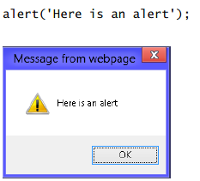

1. **PROMPT** : returns a string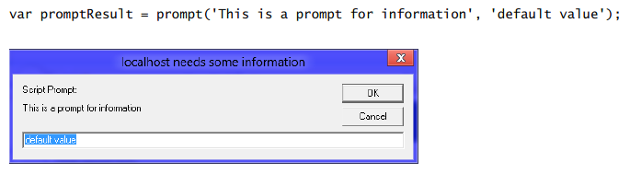
2. **CONFIRM:** Returns a boolean



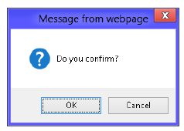

## JavaScript variable scope

I recommend that brushing your teeth that you use scope mouthwash. It’s a good call! It’ll leave your breath smelling minty clean! Oh, you didn’t want to hear about scope? What then? Oh variables. Well Okay. Here is what you need to know:

* **There are two scopes: global and local.**
* **Local scope** means that variables declare in a function are only accessible within that function.
  + Declaring variables in local scope requires using the var keyword.
    - E.g. var variable = 5;
* **Global scope** means that variables declared are accessible from anywhere.
  + Declaring variables in global scope requires not using any keyword.
    - E.g. variable = 5;
* **Scope of nested functions:**

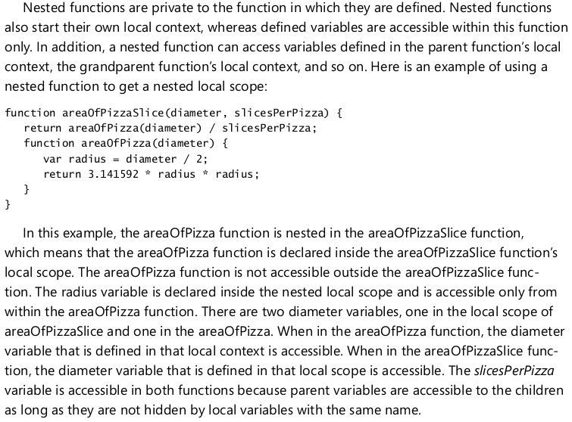

## Converting between types

You can convert between different types! Yeah nothing special here. We all know that’s possible in every other language. So why not this one too?

* Convert to a number using the function Number(string)
* Convert to a string using the function String(object)

## JavaScript loooooooooops!!

### While loop

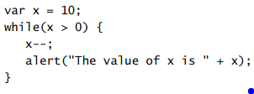

### Do While loop

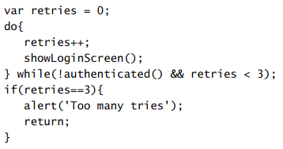

### For loop

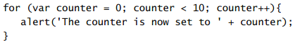

## Handling Errors: Try Catch Finally

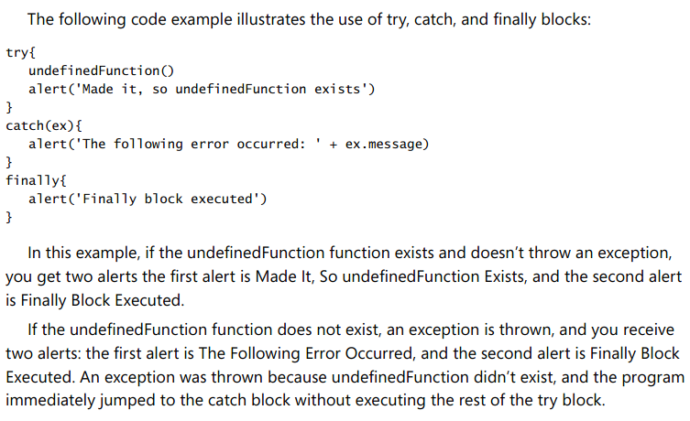

# The script tag!!!

The script tag is awesome and I’ll show you why!

## Using the script tag to define inline javascript

You can use the script tag to define inline javascript.

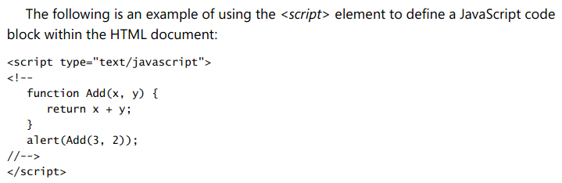

## Using the script tag to reference an external javascript file



* The script tag must be empty

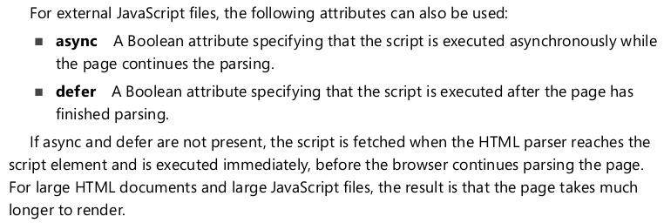

## Handling browsers that don’t support JavaScript



## Where in HTML to place your Script tags

You can maximize performance by placing your script tags in the proper place.

* Place your script tag at the end of your HTML document, so that the browser doesn’t stop parsing HTML to import your JavaScript.
* Place your script tag after your CSS reference, so that the browser can render your JavaScript and CSS at the same time.